Meta Title:
Esthetician/ Nail Tech School in Houston, TX
Meta Description:
Become the professional you always wanted at Image Academy with our complete Esthetician/Nail Tech course. Let the journey to success begin!

Esthetician/ Nail Tech Page
https://imageacademy.org/esthetician-nail-tech/
Esthetician/ Nail Tech
Esthetician/Nail Tech course | 10 | 0
Nail Tech programs | 10 | 0
 | 320 | 35

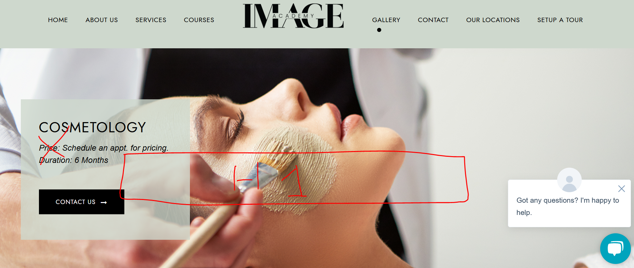

Esthetician/ Nail Tech School in Houston, TX
Get Quality Esthetician / Nail Training only at Image Academy!
Enroll Now!



Master the Art of Esthetician/ Nail Tech Training With Image Academy:
We at Image Academy work hard to equip you with the best esthetician/nail tech training. Some of the highlights of our complete courses include helping you perfect the core skills needed for the career and incorporating current trends and requirements into your knowledge.
At Image Academy, students have the opportunity to practice in great facilities alongside great instructors, ensuring they stand out from their competitors in the beauty industry. That is why our instructors give every student proper attention and support to succeed in their chosen education level.
Moreover, we teach students about the fresh concepts of learning, expertise, and development, providing them with the esthetic knowledge and skills required to succeed in their esthetics and nail tech careers. Don’t let this chance slip and advance your career while becoming integral to our growing family of happy beauty specialists. Join our Esthetician/ Nail Course today and get the help you need to make your dreams come true.

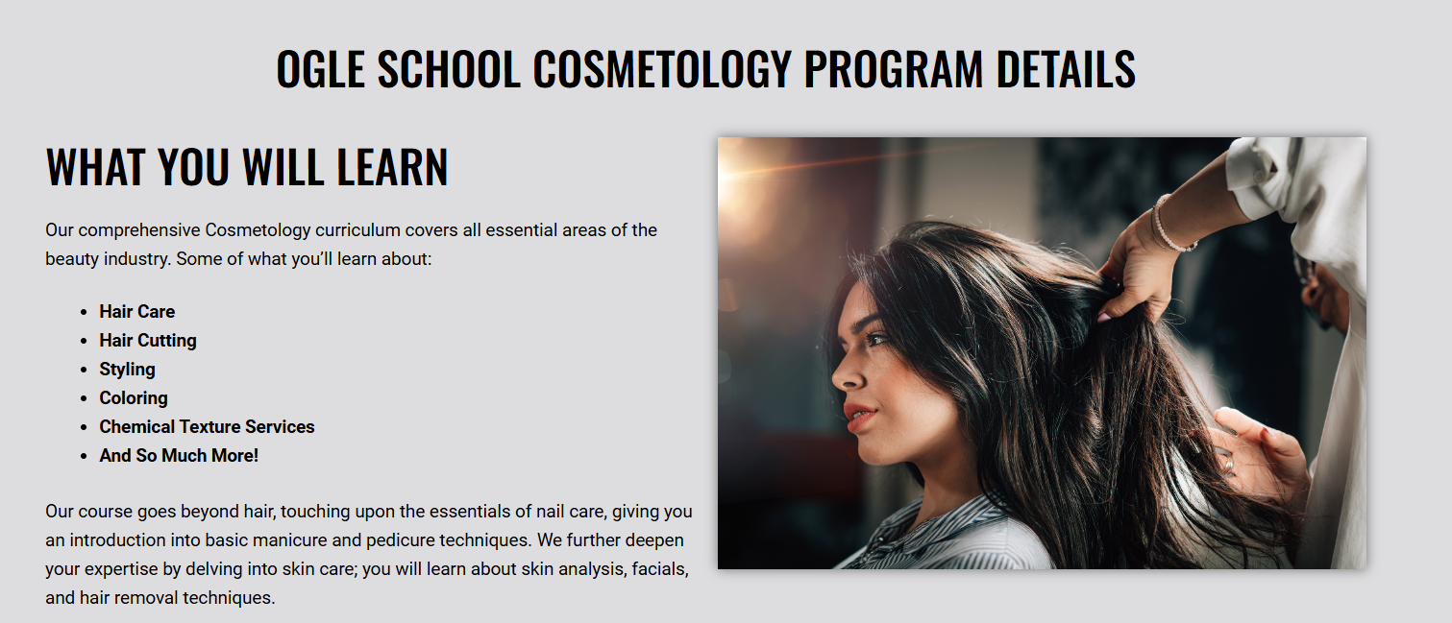

Image Academy Esthetician/Nail Tech course Detail:

What Students Will Learn?
At Image Academy, our Esthetician/nail tech programs offer training and education opportunities for beauty professionals. Students will learn a wide range of essential skills, including:
- Anatomy of Nails & Skin
- Sanitation & Infection Control
- Manicures
- Pedicures
- Nail Enhancement
- Nail Art
- Gel Polish Application
- E-Filling
- Nail Repair
- Specialty Nail Shapes
- Custom Nail Extensions
However, our entire program shall provide practical sessions and be comprised of competent trainers. Upon graduation, students will be well-equipped to join the beauty industry competently and be in a position to practice the skills they learned all through. Enroll in Image Academy now and be on your way toward being one of the best estheticians or nail techs out there!



Start Your Esthetician/ Nail Tech Journey with Image Academy Now!
Start your worthwhile career in the exciting field of Esthetician & Nail at Image Academy. Our esthetician & nail tech courses prepare you for that profession since they give you the necessary skills to do so. Get customers practical experience and obtain exposure to some of the best equipment in the market. When you finish our program, you’ll be a competent professional having the confidence to excel in the workplace. Don’t wait; begin your journey today, and let Image Academy be your pathfinder. Make yourselves great by opening the door to Success.
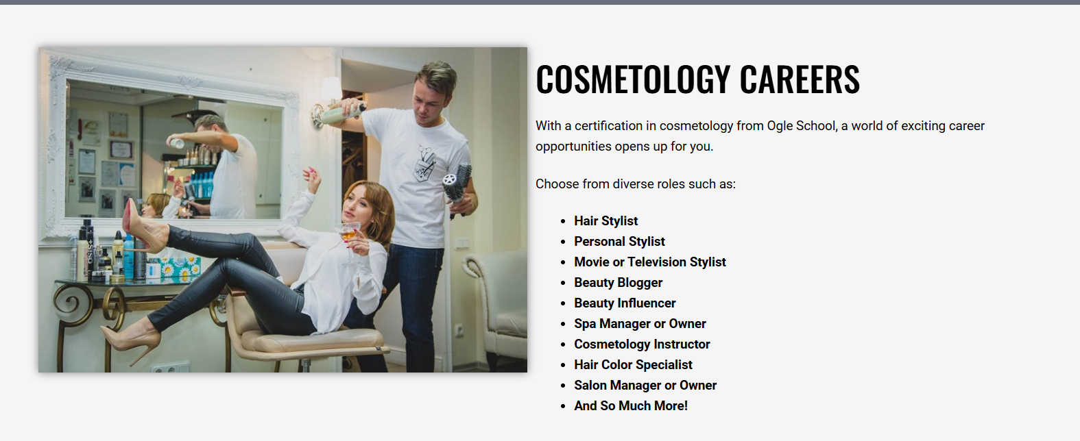

Cosmetology Careers:
By taking advantage of our extensive programs, students can open the door to an almost limitless career in this growing field. Our diverse range of roles includes:
- Esthetician & Nail Technician in Glamorous Salons
- Esthetician & Nail Art Instructor
- Mobile Esthetician & Nail Technician
- Esthetician & Nail Blogger or Influencer
- Esthetician & Nail Salon Manager or Owner
- Nail Care Advisor, Nail Care Entrepreneur
- Esthetician & Nail Specialist for Films and TV Series
Upon completing our esthetician/nail course, you will be well suited for an exciting job in the beauty industry. You will be fully equipped to change clients' lives through proper esthetician and nail treatments. Become part of the Image Academy and transform your potential into greatness within the realm of esthetician and nail tech industry.

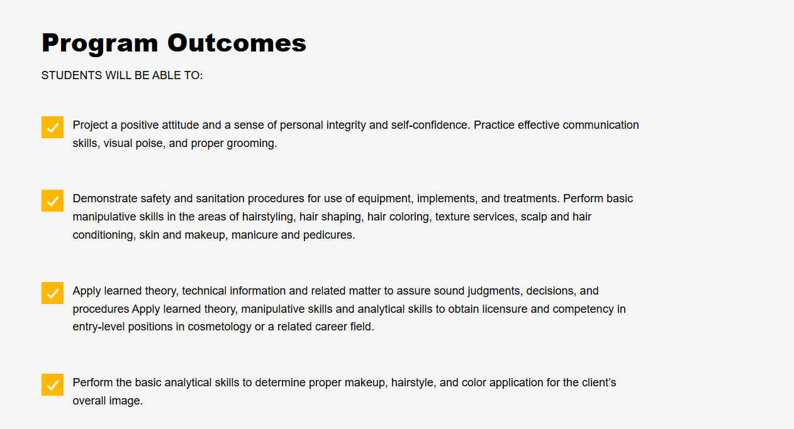

Outcomes of the Program:
Students will be able to:
- Image Academy program gives our esthetician/nail students all the information they need to succeed in their beauty careers through gaining critical skills related to the necessary work.
- The necessity to apply the skills will be met as students engage in practicals by applying the knowledge gained in the program. This is especially important for the student's development and preparation for a career.
- Estheticians and nail technicians who complete the Image Academy esthetician/nail program will receive recognized professional certification, which indicates to potential employers and customers that they are qualified and experienced.
- Our staff will also be focused on helping students find jobs that suit them best.

Start Your Journey toward Becoming an Esthetician & Nail Expert Today!

As one of the best beauty schools, we provide programs to help you become a professional in the field of beauty industry. What we know at Image Academy is that it is always good to learn from the best. You will understand every technique from educated and experienced instructors to ensure you become a great esthetician and nail expert. Moreover, students can use our ultra-modern training facilities and high-quality equipment to practice the profession as they like.

With Image Academy's Esthetician & Nail Course, you can build a bright future and open a world of possibility in the beauty industry.



Join us today! | Enroll now!

Mrs Rios (h3)

Meet Mrs Rios Master Esthetician/ Nail Trainer at Image Academy will not only help you level up your game, but she will ensure your position as one of the leading specialists in the world of Esthetician/ Nail Tech.
Sign up for the Mrs Rios Esthetician/ Nail program and train with one of the best to take your career to the next level.

MRS. SKANDER
MRS. SKANDER is an inspiring and hardworking Esthetician/Nail instructor at Image Academy, seeking to equip students with quality education and skills, self-confidence, and success.

Enrol for Mrs. Skander’s course now and transform your life towards a bright future with a successful career in the Esthetician/Nail field.

